DISCOURSE: STUDIES IN THE CULTURAL POLITICS OF EDUCATION 2021, VOL. 42, NO. 3, 425–439 https://doi.org/10.1080/01596306.2019.1709157
Vicente Llorent-Bedmar , Verónica Cobano-Delgado Palma and María Navarro-Granados
Departamento de Teoría e Historia de la Educación y Pedagogía Social, Universidad de Sevilla, Seville, Spain
ABSTRACT
Violent radicalisation is one of the most serious problems jeopardising the peaceful coexistence of many modern societies. In recent years, different research has been performed on the processes of violent radicalisation linked to terrorism and instigated by men. Following the recent increase in the number of women joining Daesh or Al Qaeda, this study examines the persuasive messages that both convey to Muslim women through their official online magazines. Using Atlas.ti software, a qualitative content analysis was conducted on all the articles aimed specifically at women published in these magazines. These groups see women as the cornerstone of the Muslim community, assigning them a key role in its survival and highlighting their contribution to the reproduction and education of future generations. Nonetheless, it has been possible to detect differences and contradictions in the role that these groups give women in violent jihad. The results obtained here contradict the general assertion that women are prompted to join these groups by promises of romance, pointing instead to different factors making them more vulnerable to influence. In conclusion, real decolonisation and educational preventive measures on which a consensus has been reached with the Muslim community are recommended.
Introduction
KEYWORDS
Islamic groups; online magazine; prevent; women; extremism; education
There has recently been an exponential increase in the number of terrorist acts carried out by lone wolves or violent collectives, who justify them through an interpretation of Islam in which there is room for violence (Kibble, 2016). At present, violent radicalisation is one of the main threats to global peace and coexistence (European Commission, 2018).
Care should be taken when referring to the moderate/radical or good/bad Muslim dichotomy (Cherney & Murphy, 2016). Although if there is a term that has been mis- interpreted time and again that is ‘jihad’. Literally meaning ‘effort’ (Shah, 2014), it is a complex word that by no mean refers exclusively to armed struggle. As with any sacred text written in a previous age, to understand this and other concepts appearing in the Qur’an it is essential to take into account the historical context of the verses in
CONTACT Verónica Cobano-Delgado Palma cobano@us.es © 2020 Informa UK Limited, trading as Taylor & Francis Group
426 V. LLORENT-BEDMAR ET AL.
question (Arya, 2017). An aspect that is usually ignored by specific groups so as to make an interpretation that legitimises their ideology (Frissen, Toguslu, Van Ostaeyen, & d’Haenens, 2018).
Since the leader of the self-proclaimed Islamic State (Daesh), Abu Bakr al-Baghdadi, announced the establishment of a ‘caliphate’ in Syria and Iraq in 2014, a large number of Muslims residing in Europe have joined its ranks. In recent years, this group has eclipsed what many consider to be its predecessor, Al Qaeda, founded in 1988 and a benchmark for global terrorism since the 9/11 terrorist attacks in 2001 (Reinares, 2015).
Research on violent radicalisation has increased over the past decade (Abdullah, Sukma, Jamhari, & Musa, 2012; Koopmans, 2015; Zhirkov, Verkuyten, & Weesie, 2014). One of its most notable findings is that there is no sole determining factor prompting an individual who has been sharing radical ideas to commit an act of violence. On the contrary, it is an extremely complex process resulting from a combination of factors whose influence depends on an individual’s receptiveness to the ideology of these groups (Campelo, Oppetit, Neau, Cohen, & Bronsard, 2018).
The fact that an increasingly larger number of European Muslim women have joined these groups (Sjøberg, 2017) has baffled specialists in the field. These so-called ‘jihadi brides’ are often considered mere victims or passive actors, arguing that they have been encouraged to join these groups by the romantic promises of a Mujahid1 (Saltman & Smith, 2015). For some authors (Gielen, 2018; Nuraniyah, 2018), this is a reduc- tionist view.
Different studies and reports have examined the factors and motives with a bearing on the recruitment of women. The Radicalisation Awareness Network (RAN), a platform created by the European Commission, refers to the following factors or reasons: (1) promises of marriage; (2) the need to have a sense of belonging to a group; (3) identity conflicts; (4) perceived injustice; and (3) feelings of discrimi- nation (RAN, 2015). In view of the results of a biographical analysis of individuals who had committed acts of terrorism, Jacques and Taylor (2008) established that men were driven mostly by political and religious reasons, especially their disconfor- mity with Western foreign policy towards Arab countries, while women tended to be more motivated by feelings of discrimination. Likewise, Brugh, Desmarais, Simons- Rudolph, and Zottola (2019) note that men tend to join Al Qaeda, while women prefer more recently created groups such as Daesh, before concluding that female radicalisation is a more recent phenomenon.
After analysing the social networks of Western Muslim female recruits, Loken and Zelenz (2017) concluded that they were mostly prompted by a religious discourse, with very strict gender norms (Windsor, 2018).
Nor is there currently a consensus on the role that Daesh and Al Qaeda assign women in jihad. According to Sjøberg (2017), both groups limit this role to that of mother and wife. However, Saikal (2016) holds that Daesh defends the participation of women in violent jihad, while Al Qaeda assigns them a supportive role.
Thus, the aim of this paper is to analyse the messages that both groups convey to Muslim women through their official online magazines, based on studies advocating for further research into female radicalisation processes (Morgades, Raynal, & Chabrol, 2018) in order to gain a better understanding of the reasons that might lead them to join Daesh or Al Qaeda.
DISCOURSE: STUDIES IN THE CULTURAL POLITICS OF EDUCATION 427
The role of education in light of radicalisation in the digital age
In the current digital age, online radicalisation is one of the main items on the counter-ter- rorism agenda (European Parliament, 2017). In this technologically very advanced transna- tional phenomenon, the Internet is the main channel for disseminating this kind of propaganda (European Commission, 2016), so much so that the media campaigns of Daesh and Al Qaeda are considered to be the most effective ever (Rudner, 2017). Their purpose is to educate and shape the identity of the younger generations (Peresin & Cervone, 2015) with an eye to recruiting them.
The Internet facilitates and, in turn, accelerates ‘self-radicalisation’ processes (Kadivar, 2018), without the need for physical contact between the recruit and recruiter (Von Behr, Reding, Edwards, & Gribbon, 2013). And, unlike other digital media, online magazines preserve the anonymity of readers (De Leede, Haupfleisch, Korolkova, & Natter, 2017).
According to Aly, Macdonald, Jarvis, and Chen (2017), digital radicalisation consists of three phases: (1) ‘pre-radicalisation and self-identification’, in which the individual begins to feel attracted to the ideology advocated by the group in question; (2) initial indoctrination once the ideology has been accepted; and (3) contact with the recruiter and members of the organisation in order to join the jihad, resorting to violence when deemed necessary.
The current digital age is a very hazardous time for young people without an adequate education (Gou & Dezuanni, 2018). Furthermore, many second- and third-generation Muslim youths are using the Internet increasingly more as a medium for learning about Islam (Aly et al., 2017).
Accordingly, the UNESCO (2017) has recommended the urgent implementation of pre- ventive educational measures. The accent has been put time and again on the crucial role that (formal, non-formal and informal) education can and should play in fostering resist- ance and critical thinking among young people (Morris, 2016). Moreover, in the most recent version of the EU Strategy for Combating Radicalisation one of the main goals is the prevention of online radicalisation (Council of the European Union, 2014).
First and foremost, a concerted effort should be made to get to the root of the afore- mentioned political, economic and social problems that, more often than not, lead to feel- ings of injustice among the Muslim community (Romero & Troyano, 2013). Secondly, ‘It is not enough to counter violent extremism – we need to prevent it. [...] No one is born a violent extremist’ (UNESCO, 2017, p. 1). To this end, we believe that the undeniable poten- tial of informal education for young people, especially through new information and com- munication technologies, should be recognised (Llorent, 2012), and that it is necessary to go beyond security-based strategies, adopting educational measures that avoid potential risks (Giscard d’Estaing, 2017).
Methodology
This qualitative study is based on a content analysis methodology very widely used to analyse digital content, insofar as it helps to understand the message (Montes, García, & Menor, 2018).
In line with Oleinik, Popova, Kirdina, and Shatalova (2014), three experienced coders performed a preliminary analysis including the following: (1) an exhaustive review of
428 V. LLORENT-BEDMAR ET AL.
the scientific literature on the object of study; (2) a preliminary review of the online maga- zines analysed here; and (3) a brief reading of all those articles aimed at women.
Given the lack of research with objectives similar to those detailed in this study, each coder then produced a rough draft of a dimension and category system based on thematic criteria (Miles & Huberman, 1994) and an inductive process deriving from the reading of the articles analysed here (Schatzman & Strauss, 1973), which were then reviewed to create a unified dimension and category system. To this end, we took into account the degree of clarity and relevance to the object of study of each category. In order to ensure inter-coder agreement in relation to the ultimate inclusion of the categories, we employed Krippendorff’s alpha coefficient to measure reliability, using SPSS v.24 statistical software and the KALPHA macro proposed by Hayes and Krippendorff (2007) for ordinal variables. The results confirmed an optimum inter-coder reliability for criteria clarity and relevance α = .843 (α > 0.8 according to Krippendorff, 2018). Thus, four major categories were identified – namely, (1) references to the sacred texts, (2) the reasons to wage jihad, (3) the reasons to make hijrah and (4) the role of women in jihad – along with a total of 23 thematic categories.
We employed Atlas.ti v.7.5 qualitative analysis software for the data analysis.
Magazines researched
We selected the English-language versions of Al Qaeda’s and Daesh’s three official propa- ganda magazines, all retrieved from jihadology.com.
- . Inspire. Al Qaeda’s first English-language magazine, with 17 issues between 2010 and 2017 and an average of 45 pages per issue.
- . Dabiq. Daesh’s magazine of which 15 issues, with an average of 61 pages per issue, were published between 2014 and 2016.
- . Rumiyah. The magazine replacing Dabiq, whose 13 issues, each with 45 pages on average, were published between 2016 and 2017.
We chose these magazines for several reasons: (1) they are one of these groups’ main media communication channels and offer a comprehensive overview of their discourses (Novenario, 2016); (2) they have a clear educational purpose, i.e. to shape the perceptions of their readers (Ingram, 2016); and (3) they are mostly aimed at a Western audience (Colas, 2017), easy to access and available in several languages.
Our object of study included 26 articles specifically aimed at Muslim women or expli- citly mentioning them, published in these three magazines between January 2011 and September 2017 (see Table 1):
Results
General data
All the articles published in Al Qaeda’s magazine are signed by the authors, 80% by women and 20% by men, while only 33.3% of those published in Daesh’s two magazines are signed by women.
Table 1. Articles analysed in Daesh’s and Al Qaeda’s magazines.
DISCOURSE: STUDIES IN THE CULTURAL POLITICS OF EDUCATION 429
Magazine Year I 2011
I 2013 I 2013 I 2014 I 2015 D 2015 D 2015 D 2015 D 2015 D 2015 D 2015 D 2016 D 2016 R 2016 R 2016 R 2016 R 2016 R 2017 R 2017 R 2017 R 2017 R 2017 R 2017 R 2017 R 2017 R 2017
Month Issue
January 4 March 10a March 10b
Title
Roshonara & Taimour: Followers of the Borderless Loyalty Women of the Glorious Ummah
My wish: if only I was a mujahid
Mujahidah, Wife of a Mujahid
My little boy
A brief interview with Umm Basir Al-Muhajirah
The twin halves of the muhãjirin
Slave-girls or prostitutes?
They are not lawful spouses for one another
A jihãd without fighting
Two, three, or four
Advice on Ihdãd
The Fitrah of mankind and the near extinction of the Western woman O women! Give charity
Stories of Steadfastness from the Lives of the Sahabiyyat
Abide in your homes
Marrying widows in an established Sunnah
I will outnumber the Other Nations through you
Wala and Bara, O women
The flesh of your spouse is poisonous
Zuhd in the Dunya is the way of the salaf
The woman is a shepherd in her husband’s home
Be a supporter, not a demoralizer
Our journey to Allah
The female slaves of Allah in the houses of Allah
The Hijrah of Umm Sulaym Al-Muhajirah
March September February March May
July September November January July September October November December January February March April
May
June
July August September
12 13 7 8 9 10 11 12 13 15 1 2 3 4 5 6 7 8 9 10 11 12 13
Note: R = Rumiyah magazine; D = Dabiq magazine and I = Inspire magazine.
In the magazines published by Daesh, 81% of articles pertaining to women are included
in a specific section, as opposed to only 20% in Al Qaeda’s magazine.
References to the sacred texts
As to quotes from the Qur’an, these appear in 60% of the articles published by Al Qaeda and in 90% of those published by Daesh. In a preliminary analysis, we detected quotes from the sacred texts in almost all the paragraphs of the articles appearing in Dabiq and Rumiyah, while those published in Inspire included one or two at most (see Figure 1):
The surahs of the Qur’an are divided into two periods – Mecca and Medina – the latter describing the Prophet Muhammad’s hijrah from Mecca to Medina. Al Qaeda tended to resort to the Meccan surahs (67%), while Daesh preferred the Medinan surahs (72%).
Reasons to make jihad and hijrah
Al Qaeda and Daesh deploy the same arguments to justify jihad: (1) jihad is a religious obli- gation imposed by Allah and explicitly described in the sacred texts; (2) the suffering of the Ummah or Muslim community due to their humiliation and oppression, alluding to this effect to the bombings and children as innocent victims, etc.; and (3) the war against Islam waged by the West (see Figure 2):
Unlike Al Qaeda, Daesh has prioritised the construction of a ‘caliphate’ and has had no qualms about highlighting violence as a modus operandi:
430 V. LLORENT-BEDMAR ET AL.
Figure 1. Percentage of paragraphs including quotes from a sacred text.
Here we are today reviving a prophetic Sunnah, which both the Arab and non-Arab enemies of Allah had buried. By Allah, we brought it back by the edge of the sword, and we did not do so through pacifism, negotiations, democracy or elections. (D. 9)
It maintains that hijrah, from the land of the infidels (‘Dar al-Kufr’2) to the land of Islam (‘Dar al-Islam’), is an obligation for both sexes:
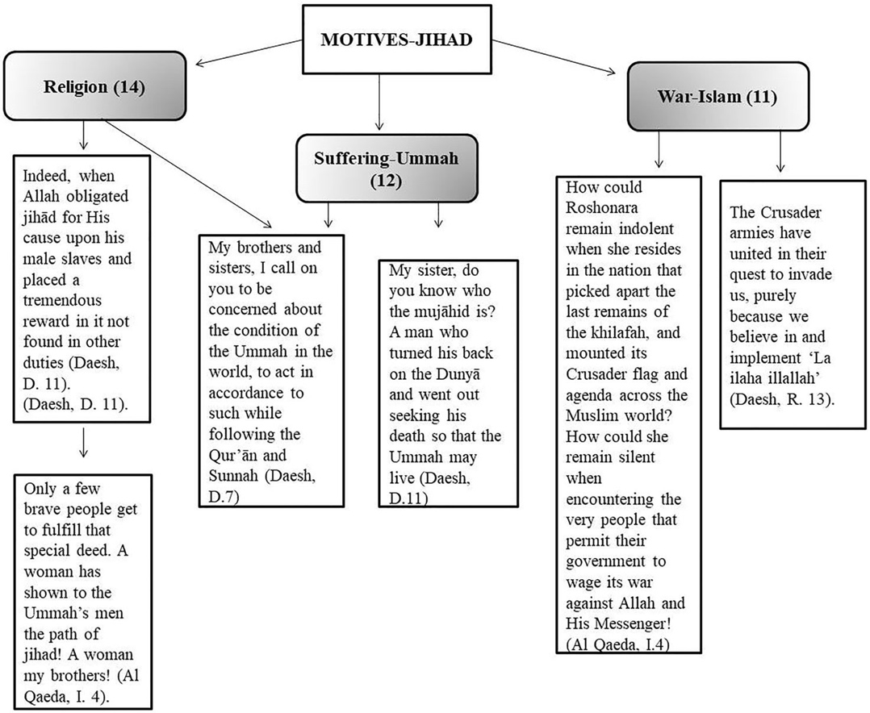
Figure 2. Conceptual diagram: ‘reasons for jihad’.
DISCOURSE: STUDIES IN THE CULTURAL POLITICS OF EDUCATION 431
- (1) MuslimsmustliveinalandgovernedbyIslamiclaw.Noteworthyisanarticlecomple- tely dedicated to criticising Western education (see Figure 3: D. 15), which it literally considers to be at ‘war’ with Islam. Likewise, in another article a woman claims that her reason for making hijrah was for her children to grow up and to be educated in the land of the caliphate (R.13).
- (2) Inthe‘wagingjihadagainsttheenemy’category,thequotefeaturinginFigure3(D.8) should be noted.
- (3) In rare cases, pretexts included joining the Muslim community to support and strengthen it (D. 8), while being tired of living in the West is only mentioned on two occasions. They criticise Islamic scholars in Western countries for failing to help the weakest and most oppressed, while stressing that women should not decide to make hijrah prompted by poverty or misfortune in their home societies.
Jihad and the educational role of Muslim women
Eighty percent of the articles published by Al Qaeda refer to women as ‘the woman/wife of’ and 60% as ‘the mother of’. In Daesh’s two magazines, these roles are mentioned in
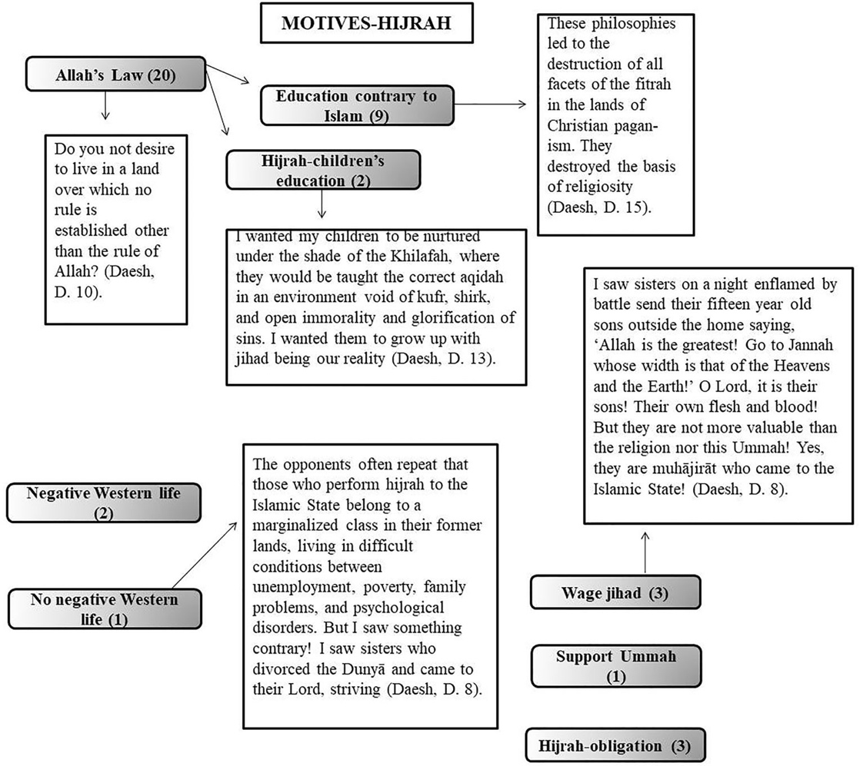
Figure 3. Conceptual diagram: ‘reasons for making Hijrah’ according to Daesh.
432 V. LLORENT-BEDMAR ET AL.
86% and 57% of articles published, respectively. What follows is a brief explanation of the roles assigned to women in jihad by both groups.
Women’s training/education
Both groups hold that women have the obligation to learn about religious matters (see Figure 4). Daesh conveys the message that the ‘state’ is generous towards women, offering them institutions and courses on the sciences of Sharia (D. 11). They also maintain that women mistakenly assume that understanding the sacred texts requires the interpret- ation of an imam or scholar (D. 7) and are instead encouraged to educate themselves.
Children’s education
Al Qaeda and Daesh consider that one of the most important roles of women in jihad is to educate their children, this being the most frequently observed in the qualitative analysis (see Figure 4).
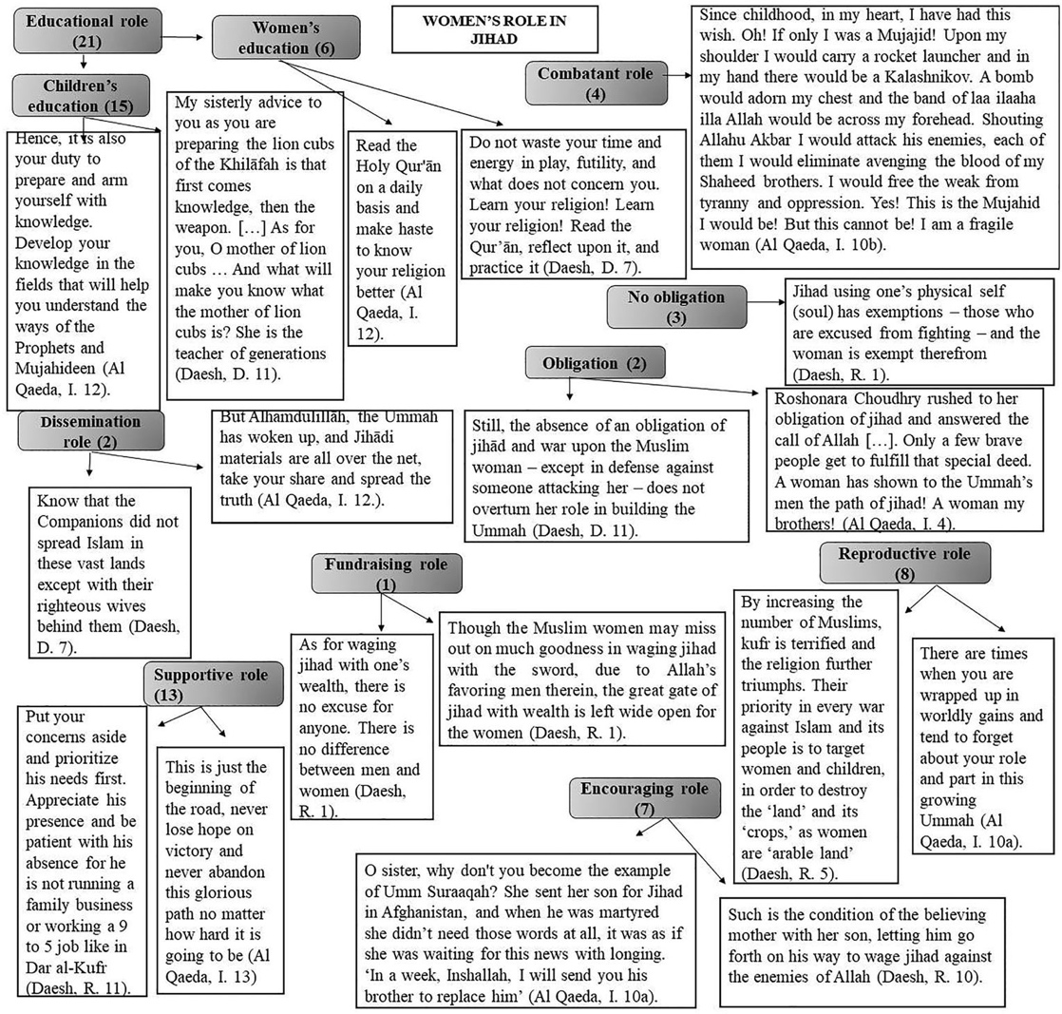
Figure 4. Conceptual diagram: the ‘role of women in jihad’.
DISCOURSE: STUDIES IN THE CULTURAL POLITICS OF EDUCATION 433
Daesh attaches great importance to the education of children born in the land of the caliphate (R.5). It insists that women must take advantage of the opportunity which Allah has given them to give birth in their ‘state’ and educate their children in the interests of the Ummah, ‘under the wing of a mujahid father’ (R. 9), also explaining how and what they should teach their children:
- . They have to educate them in religious matters, paying special attention to teaching them correct Arabic. They are also told that while Western women educate their chil- dren with fairy stories, Muslim women must teach their children stories about religious figures (D. 11).
- . They have to make their children understand that the Dunya3 is a place of transit, some- thing trivial, the ‘afterlife’ (paradise) being their true concern (R. 9).
- . They have to instil in them a desire for jihad and a loathing for their enemies (D. 11). For Al Qaeda, children are taught Islam only in order that they should be prepared to
fight for their religion (I. 10a and 12).
Supportive role
Daesh tells women that ‘being a support to their Mujahid husbands is one of their key roles in the land of jihad’ (R. 11), while Al Qaeda encourages them to be patient while the men are waging jihad, avoiding becoming an obstacle in their husbands’ path to paradise (I. 10a) and providing a shoulder for them to cry on in times of difficulty (I. 12).
Combatant role
This role is solely assigned to women by Al Qaeda which explicitly addresses them as ‘Mujahidah’ (I. 12). The group praises the ‘lone wolf’ terrorist attack carried out by the British woman Roshonara Choudhry against British MP Stephen Timms (I. 4). However, some contradictions are observed as regards this combatant role when a woman expresses the desire to be a Mujahidah but eventually rejects this possibility (I. 10b).
In contrast, Daesh excludes women from violent jihad (R. 1), except for self-defence (D. 11).
Reproductive role
Women are encouraged to contribute to jihad by bearing future Mujahideen with a view to strengthening the Ummah. Daesh dedicates an entire article to this issue (R. 5), in addition to claiming that this will be ‘a generation which will wage jihad for His cause and bring victory to His religion’ (R. 9).
In the same vein, Al Qaeda considers women to be the ‘mothers of the upcoming gen- eration’; specifically stating that one of their most important roles is the growth of the Ummah (I. 10a).
Encouraging and fundraising roles
Both groups urge women to encourage their loved ones to wage jihad (R. 10; I. 10a). Women’s role as fundraisers is only mentioned by Daesh on one occasion. This group openly criticises Muslim women who spend extravagantly on frivolous, mundane con-
cerns, such as clothing, jewellery, parties, etc., instead of helping their religion (R. 1).
434 V. LLORENT-BEDMAR ET AL.
Women as promoters
Both groups assign women an important role in dissemination. Al Qaeda indicates that they must spread propaganda, after explaining that its enemies (the mass media and those who claim to be Islamic scholars) spread lies to alienate young people from the cause (I. 12). Daesh, however, limits itself to the promotion of Islam (D. 7).
Discussion and conclusions
The aim of this study has been to analyse the messages conveyed by Daesh and Al Qaeda to Muslim women through their official online magazines. Accordingly, this has helped to remedy the virtual absence of research on Dabiq and Rumiyah, the two official magazines published by Daesh (Sjøberg, 2017), which to date has only been addressed Al Qaeda’s magazine Inspire (Droogan & Peattie, 2018). In neither case were articles aimed at women analysed.
The results reveal fundamentally strategic differences between both groups. Daesh prioritises the creation of its ‘state’, in which women play a key role. It resorts more to the Meccan surahs of the Qur’an, framing them in a modern context to convince women that their emigration to the caliphate is a religious obligation, just as it is for men, and an opportunity to educate their children under Islamic law. In contrast, Al Qaeda focuses exclusively on the importance of waging jihad against the West.
Both use quotes from the sacred texts in a high proportion of their articles. However, Daesh’s are more theological than those of Al Qaeda.
As regards the reasons for waging jihad, both organisations strive to convey the message that this is an obligation imposed by Allah and the only form of defence in the ‘war against Islam’, led by the West.
As demonstrated in other studies (Abdullah et al., 2012; Koopmans, 2015; Zhirkov et al., 2014) there is no single factor behind violent radicalisation. Of all the factors shown to have an effect on the recruitment of women by these groups (RAN, 2015), we have not detected any references to promises of romance or marriage to a Mujahid. In this regard, we fully agree with those authors for whom the ‘jihadi bride’ discourse is reductionist (Gielen, 2018; Nuraniyah, 2018). Nor were we able to find any references to Muslim women’s feelings of exclusion or discrimination in Western societies as motivating factors that in other studies (Jacques & Taylor, 2008) have been exclusively associated with women.
In contrast, particularly relevant factors include identity conflicts and feelings of per- ceived injustice. The former are emphasised primarily by Daesh to stress the differences and incompatibilities between Islam and the West. Furthermore, both groups underscore and foster feelings of injustice, referring to the suffering, oppression and humiliation suffered by the Ummah in Arab countries. This can lead to acts of self-defence in the belief that jihad is a legitimate form of defence. Unlike the studies that only attribute pol- itical-religious motives to men, relating to their dissatisfaction with Western foreign policy vis-à-vis the Arab states (Jacques & Taylor, 2008), our results allow us to claim that women have strong ideological-political motives and highly defined gender roles (Loken & Zelenz, 2017).
Nevertheless, as our analysis focuses exclusively on the messages conveyed by Daesh and Al Qaeda to Muslim women, we have not been able to deduce the real reasons prompting them to join these groups.
DISCOURSE: STUDIES IN THE CULTURAL POLITICS OF EDUCATION 435
In line with authors like Sjøberg (2017), it has been possible to observe that both groups assign women a crucial role in jihad in their status as mothers and wives. We disagree with authors who contend that this role is secondary (Windsor, 2018). Our results show that both groups see women as indispensable to the continuity of their project, in charge of procreating and educating future generations in their ideology.
We do not completely agree with Sjøberg (2017) who holds that both groups exclude women from violent jihad, since we have identified contradictory messages conveyed by both in this regard.
Although authors like Windsor (2018) conclude that women who join Daesh have no truly realistic expectations of the life that awaits them, far from painting the picture of an idyllic life, the articles analysed here refer specifically to their obligation to educate their children in violence. This shows that at least those women radicalised by reading these magazines, whose articles openly criticise Western ways of life, values and beliefs, such as feminism, consumerism and Christianity are aware of their interpretation of Sharia.
Considering the purely educational purpose of these magazines (Peresin & Cervone, 2015) and the evident value that both groups attach to educating the younger gener- ations, Giscard d’Estaing (2017) suggests implementing educational measures that go beyond mere security-based strategies. Input from the Muslim community is indispensa- ble in this regard.
We also believe that prevailing Western attitudes and policies towards the Middle East, giving rise to strong feelings of injustice and discrimination, should be changed. The hege- monic pretensions of some of the region’s states, which have had no qualms about lever- aging the current socio-political-religious situation, and the constant interference of the major powers paint a picture of conflicting interests that is shaping a new and unpredict- able geopolitical map endangering the artificial borders drawn by the West (Kaplan, 2011, p. 13). In this region, the epicentre of Islamic-inspired violent radicalism, both Salafism – a firmly established Islamic current that is dead against the Westernisation of society – and the emerging Pan-Islamic ideology fuelled by the citizenry’s rejection of authoritarian regimes (Mishra, 2014), have favoured the advent of this violent extremism. This phenom- enon should be addressed from a broader perspective in which social welfare takes pre- cedence, implementing preventive and moderate policies that do not provoke unwelcome reactions and that take into consideration the broad diversity and heterogen- eity of peoples, cultures, economic and social statuses and even Islamic schools.
We concur with the UNICEF (2005) when it declares that in the Middle East special attention should be paid to education, because it is producing and reinforcing the social discrimination and the economic and political inequalities suffered by women and girls. To this end, a change in Western attitudes and policies that give rise to feelings of injustice and discrimination must necessarily be supplemented by digital literacy pro- grammes, on the basis of an analysis of this propaganda and awareness raising/training through networks.
After analysing the messages conveyed by both groups, we have noted the importance of deploying arguments that foster social cohesion, stressing the fact that Islam and the West are not incompatible. In short, there is a need for education that counters the regret- table ‘clash of civilisations’.
We advocate for the inclusion of a gender perspective in the strategies implemented, as in countries like the United Kingdom (RAN, 2015). Although it is
436 V. LLORENT-BEDMAR ET AL.
best to avoid the widespread Western-centric epistemological colonialism whose aim is to impose a model of the modern woman by empowering Muslim women (Martino & Rezai-Rashti, 2008) to confront their culture and/or religion and by hindering the development of alternative projects for their emancipation. This is especially danger- ous for many Muslim immigrants who are immersed in the difficult process of rebuild- ing their identity.
Perhaps different historical and cultural restraints have prevented Islamic case law or fiqh from fully complying with the Prophet Muhammad’s wish, to wit, the social advance- ment of women. But, be that as it may, unlike Sharia (of a divine character), the different fiqh are the product of human intellectual activity and, as such, a fallible science suscep- tible to being modified. We consider that, with a new Qur’anic hermeneutics adapted to current social reality, it may be possible to achieve greater equality between men and women. We are of the opinion that a holistic understanding of divine will requires an exeg- esis that considers the new roles of women in current societies. As regards the two most significant and controversial Qur’anic verses dealing with the relations between men and women (4:34 and 33:354), an interpretative effort that reconciles the opposing stances that both engender would be advisable.
Many Muslims feel directly or indirectly victimised by the West, a victimisation per- ceived at very different levels: economic, social, cultural, etc., and even military (Romero & Troyano, 2013), thus putting them on the defensive. This perception has led to the emer- gence of radicalised groups based on an interpretation of Islam which condones violence when employed in defence of the Ummah. Ergo, we believe that it is urgent to get to the root of the problem that, in the main, lies in the devastating consequences of Western colonisation of the Middle East (Martini, 2016) and the disastrous process of decolonisation (Rubio, 2018). Understanding this reality in no way implies the defence of violent attitudes, but should indeed constitute the basis for adopting measures that bring about the much- desired peaceful coexistence between citizens of the world, irrespective of their religious beliefs.
Notes
1. Fighter.
2. Infidelorapostate.
3. Mundane,materialandfleetinglife.
4. SeetheQur’anat:https://bit.ly/2SZ34fr.
Disclosure statement
No potential conflict of interest was reported by the authors.
Funding
This paper has been written in the framework of the Research Plan of the University of Seville (VPPI- US-2016), as part of the project ‘Islam and peace through Muslim voices. Preventive socio-edu- cational measures’, funded by the Office of Development and Cooperation of the University of Seville.
DISCOURSE: STUDIES IN THE CULTURAL POLITICS OF EDUCATION 437
Notes on contributors
Vicente Llorent-Bedmar is a Senior Lecturer at Department of Theory and History of Education and Social Pedagogy of University of Seville. Past Presidente of Spanish Society of Comparative Education (SEEC). Director of the Research group GIECSE (Comparative Education of Seville).
Verónica Cobano-Delgado Palma is a professor at Department of Theory and History of Education and Social Pedagogy of University of Seville. Member of the Research group (GIECSE) (Comparative Education of Seville). Most of her work involves questions about women, Islam an education in the Maghreb.
María Navarro-Granados is a grant holder at Department of Theory and History of Education and Social Pedagogy of University of Seville. Member of the Research group (GIECSE) (Comparative Edu- cation of Seville). Most of her work involves questions about women, Islam an education in disadvan- taged contexts.
ORCID
Vicente Llorent-Bedmar http://orcid.org/0000-0003-4166-6098
Verónica Cobano-Delgado Palma http://orcid.org/0000-0001-7054-4191 María Navarro-Granados http://orcid.org/0000-0001-7054-4191
References
Abdullah, K., Sukma, R., Jamhari, M., & Musa, M. (2012). Perception and attitudes toward terrorism in a Muslim majority country. Asian Social Science, 8(4), 77–89.
Aly, A., Macdonald, S., Jarvis, L., & Chen, T. M. (2017). Introduction to the special issue: Terrorist online propaganda and radicalization. Studies in Conflict & Terrorism, 40(1), 1–9.
Arya, N. G. (2017). The Qur’an’s message on spirituality and martyrdom: A literary and rhetorical analysis. Religions, 8(8), 1–11.
Brugh, C. S., Desmarais, S. L., Simons-Rudolph, J., & Zottola, S. A. (2019). Gender in the jihad: Characteristics and outcomes among women and men involved in jihadist-inspired terrorism. Journal of Threat Assessment and Management, 6(2), 76–92.
Campelo, N., Oppetit, A., Neau, F., Cohen, D., & Bronsard, G. (2018). Who are the European youths willing to engage in radicalisation? European Psychiatry, 52, 1–14.
Cherney, A., & Murphy, K. (2016). What does it mean to be a moderate Muslim in the war on terror? Critical Studies on Terrorism, 9(2), 159–181.
Colas, B. (2017). What does Dabiq do? ISIS hermeneutics and organizational fractures within Dabiq magazine. Studies in Conflict & Terrorism, 40(3), 173–190.
Council of the European Union. (2014). Revised EU strategy for combating radicalisation and recruit- ment to terrorism. Retrieved from https://bit.ly/2wNmD0U
De Leede, S., Haupfleisch, R., Korolkova, K., & Natter, M. (2017). Radicalisation and violent extremism- focus on women. European Union. Retrieved from https://bit.ly/2zhxMsX
Droogan, J., & Peattie, S. (2018). Reading jihad: Mapping the shifting themes of Inspire magazine. Terrorism and Political Violence, 30(4), 684–717.
European Commission. (2016). Supporting the prevention of radicalisation leading to violent extremism. Retrieved from https://bit.ly/2iZmYZf
European Commission. (2018). Radicalisation. Migration and Home Affairs. Retrieved from https://bit. ly/2IfSZqu
European Parliament. (2017). Prevention of radicalisation and recruitment of European citizens by ter- rorist organisations. Retrieved from https://bit.ly/2DwdbUU
Frissen, T., Toguslu, E., Van Ostaeyen, P., & d’Haenens, L. (2018). Capitalizing on the Koran to fuel online violent radicalization: A taxonomy of Koranic references in ISIS’s Dabiq. Telematics and Informatics, 35, 491–503.
438 V. LLORENT-BEDMAR ET AL.
Gielen, A. J. (2018). Exit programmes for female jihadists. International Sociology, 33(4), 454–472. Giscard d’Estaing, S. (2017). Engaging women in countering violent extremism. Gender &
Development, 25(1), 103–118.
Gou, H., & Dezuanni, M. (2018). Towards understanding young children’s digital lives in China and
Australia. Comunicar, 26, 81–90.
Hayes, A., & Krippendorff, K. (2007). Answering the call for standard reliability measure for coding
data. Communication Methods and Measures, 1(1), 77–89.
Ingram, H. (2016). An analysis of Islamic state’s Dabiq magazine. Australian Journal of Political Science,
51(3), 458–477.
Jacques, K., & Taylor, P. J. (2008). Male and female suicide bombers: Different sexes, different reasons?
Studies in Conflict & Terrorism, 31(4), 304–326.
Kadivar, J. (2018). Online radicalization and social media: A case study of Daesh. International Journal
of Digital Television, 8(3), 403–422.
Kaplan, R. D. (2011). Monsoon. The Indian Ocean and the future of American power. New York: Random
House.
Kibble, D. (2016). Dabiq, the Islamic state’s magazine: A critical analysis. Middle East Policy, 23(3),
133–143.
Koopmans, R. (2015). Religious fundamentalism and hostility against out-groups. Journal of Ethnic
and Migration Studies, 41(1), 33–57.
Krippendorff, K. (2018). Content analysis. California: Sage.
Llorent, V. (2012). The educational role of the digital media in the integration of immigrants in Spain:
elmundo.es and el país.es. Comunicar, 19, 139–146.
Loken, M., & Zelenz, A. (2017). Explaining extremism: Western women in Daesh. European Journal of
International Security, 3(1), 45–68.
Martini, A. (2016). El terrorismo global como amenaza al orden internacional. El caso del Estado
Islámico [Global terrorism as a threat to the international order. The case of the Islamic state].
Relaciones Internacionales, 32, 79–95.
Martino, W., & Rezai-Rashti, G. M. (2008). The politics of veiling, gender and the Muslim subject: On
the limits and possibilities of anti-racist education in the aftermath of September 11. Discourse:
Studies in the Cultural Politics of Education, 29(3), 417–431.
Miles, M. B., & Huberman, A. M. (1994). Qualitative data analysis: An expanded sourcebook. Thousand
Oaks, CA: Sage.
Mishra, P. (2014). De las ruinas de los imperios. La rebelión contra Occidente y la metamorfosis de Asia
[From the ruins of empires. The rebellion against the West and the metamorphosis of Asia].
Barcelona: Galaxia Gutenberg.
Montes, M., García, A., & Menor, J. (2018). Teen videos on YouTube: Features and digital vulnerabil-
ities. Comunicar, 26, 61–69.
Morgades, C. I., Raynal, P., & Chabrol, H. (2018). Exploring the radicalization process in young women.
Terrorism and Political Violence, 1–19. Retrieved from https://www.tandfonline.com/doi/abs/10.
1080/09546553.2018.1481051?journalCode=ftpv20
Morris, E. (2016). Children: Extremism and online radicalization. Journal of Children and Media, 10(4),
508–514.
Novenario, C. M. I. (2016). Differentiating Al Qaeda and the Islamic state through strategies publicized
in jihadist magazines. Studies in Conflict & Terrorism, 39(11), 953–967.
Nuraniyah, N. (2018). Not just brainwashed: Understanding the radicalization of Indonesian female
supporters of the Islamic state. Terrorism and Political Violence, 30(6), 890–910.
Oleinik, A., Popova, I., Kirdina, S., & Shatalova, T. (2014). On the choice of measures of reliability and validity in the content-analysis of texts. Quality & Quantity, 48(5), 2703–2718. Retrieved from
https://bit.ly/2SzCZDR
Peresin, A., & Cervone, A. (2015). The western Muhajirat of ISIS. Studies in Conflict & Terrorism, 38(7),
495–509.
RAN. (2015). The role of gender in violent extremism. RAN Centre of Excellence. Retrieved from https://
bit.ly/2I9Y2IR
Reinares, F. (2015). Yihadismo global y amenaza terrorista [Global jihadism and the terrorist threat]. Retrieved from https://bit.ly/2i2MSai
Romero, A. J., & Troyano, Y. (2013). Las raíces socioestructurales del terrorismo fundamentalista islámico [The socio-structural roots of fundamental Islamic terrorism]. Convergencia, 62, 181– 198. Retrieved from https://bit.ly/2FMHSXU
Rubio, M. (2018). The unexpected Arab Spring: From the European colonization to our days. Revista Historia Autónoma, 13, 283–286. Retrieved from https://bit.ly/2RS6IMf
Rudner, M. (2017). ‘Electronic jihad’: The internet as Al Qaeda’s catalyst for global terror. Studies in Conflict & Terrorism, 40(1), 10–23.
Saikal, A. (2016). Women and jihad: Combating violent extremism and developing new approaches to conflict resolution in the Greater Middle East. Journal of Muslim Minority Affairs, 36(3), 313–322. Saltman, E. M., & Smith, M. (2015). Till martyrdom do us part. Gender and the ISIS phenomenon. London:
Institute for Strategic Dialogue. Retrieved from https://bit.ly/2ypqJiB
Schatzman, L., & Strauss, A. L. (1973). Field research: Strategies for a natural sociology. Englewood Cliffs:
Prentice Hall.
Shah, S. (2014). Islamic education and the UK Muslims. Studies in Philosophy and Education, 33(3),
233–249.
Sjøberg, A. (2017). Migrants, housewives, warriors or sex slaves: AQ’s and the Islamic state’s perspec-
tives on women. Connections, 1, 99–111.
UNESCO. (2017). Preventing violent extremism through education. Retrieved from https://bit.ly/
2oR39Gl
UNICEF. (2005). Gender parity and primary education. Retrieved from https://uni.cf/2YiDq8X
Von Behr, I., Reding, A., Edwards, C., & Gribbon, L. (2013). Radicalisation in the digital era. RAND
Europe. Retrieved from https://bit.ly/2KyWo86
Windsor, L. (2018). The language of radicalization: Female internet recruitment to participation in ISIS
activities. Terrorism and Political Violence, 1–33. Retrieved from https://www.tandfonline.com/doi/
abs/10.1080/09546553.2017.1385457
Zhirkov, K., Verkuyten, M., & Weesie, J. (2014). Perceptions of world politics and support for terrorism
among Muslims. Conflict Management and Peace Science, 31(5), 481–501.

