**Supplementary Information for**

**Distribution of potassium during chemical activation of petroleum coke: electron microscopy evidence and links to phase behaviour**

**Vicente Montes** [1]**2*, Ye Xiao1, Jingfeng Wu1, and Josephine M. Hill1**

*1 Department of Chemical and Petroleum Engineering, University of Calgary, 2500 University Dr NW, Calgary, Alberta, T2N 1N4, Canada*

*2 Department of Organic and Inorganic Chemistr, University Institute of Research in Water, Climate Change and Sustainability (IACYS), University of Extremadura, Badajoz, Spain*

*Corresponding author. Tel.: +34 924-289387; *E-mail address: vmontes@unex.es*

Table S1. Properties of some potassium and sodium species from [29].

|  |  |  |  |  |  |  |  |  |  |
| --- | --- | --- | --- | --- | --- | --- | --- | --- | --- |
| Chemical species | Molecular Weight (g/mol) | Fusion Temp.  (ᵒC) | Boiling Temp.  (ᵒC) | Density at 800 ᵒC (g/cm3) | | Viscosity at 800 ᵒC (cP) | | Surface tension at 800 ᵒC (dynes/cm) | |
| KOH | 56.1 | 360 |  |  |  | |  | |
| K2S | 110.3 | 840 |  |  |  | |  | |
| K2O | 94.2 | 740 |  |  |  | |  | |
| K2CO3 | 138.2 | 891 |  |  |  | |  | |
| K | 39.1 | 63.5 | 759 | 0.665 | 0.13 | | 65 | |
| NaOH | 40.0 | 320 |  |  |  | |  | |
| Na2S | 78.0 | 1176 |  |  |  | |  | |
| Na2O | 62.0 | 1132 |  |  |  | |  | |
| Na2CO3 | 106.0 | 851 |  |  |  | |  | |
| Na | 23.0 | 98 | 883 | 0.73 | 0.16 | | 125 | |

Calculation of theoretical pore volume by intercalation, assuming all volume ocuppied by M at 800ºC remain as pore volume in final AC.

Basis: 2 g of KOH and 1 g of carbon

Moles of KOH = $2 g KOH x\frac{1 mol KOH }{56.1 g KOH}=0.036 mol KOH$ = 0.036 mol K

Moles of K = 0.036 mol K $=\frac{39.098g K }{1mol K}X\frac{1 cm3 }{0.665 g K}=$ 2.117 cm3 occupied by K

Yield of 76% = 0.76 g of AC

Theoretical pore volume by intercalation = = 2.86 cm3/g AC

Calculation of theoretical pore volume by burn-off, assuming all volume ocuppied by the burned-off carbon remain as pore volume in final AC.

Basis: 2 g of KOH and 1 g of carbon

Yield of 76% ⇒ 24% C burn-off = 0.24 g C x 0.12 cm3

Theoretical pore volume by burn-off = = 0.16 cm3/g AC

The percentage of hydroxide (MOH) and carbonate (M2CO3) forms of the alkali metals (M) present at the activation conditions were estimated assuming that all carbon released (the burn-off) formed M2CO3. The following calculation illustrates the procedure for an initial KOH to carbon ratio of 1, 2 and 3.

Basis: 1 g of carbon and 1 g of KOH

Yield of 80% ⇒ 20% C burn-off = 0.2 g C x $\frac{1 mol C}{12 g C}x\frac{1 mol K2CO3}{1 mol C}=0.017 mol K2CO3$

Max moles of K2CO3 = , insufficient K to form amount of K2CO3 calculated from burn-off

Basis: 2 g of KOH and 1 g of carbon

Yield of 76% ⇒ 24% C burn-off = 0.24 g C x $\frac{1 mol C}{12 g C}x\frac{1 mol K2CO3}{1 mol C}=0.02 mol K2CO3$

Moles of KOH = $2 g KOH x\frac{1 mol KOH }{56.1 g KOH}=0.036 mol KOH$, insufficient K to form amount of K2CO3 calculated from burn-off (stoichiometrically, 1 mol of K2CO3 need 2 mol of KOH)

Basis: 3 g of KOH and 1 g of carbon

Yield of 72% ⇒ 28% C burn-off = 0.28 g C x $\frac{1 mol C}{12 g C}x\frac{1 mol K2CO3}{1 mol C}=0.023 mol K2CO3$

Moles of KOH = $3 g KOH x\frac{1 mol KOH }{56.1 g KOH}=0.053$ mol KOH

Equation S1. Calculation of mol% M2CO3 assuming all carbon released (the burn-off) formed M2CO3

x 100 (S1),

$Max Mol \% M2CO3=\frac{0.023}{\left(0.053-2x0.023\right)+0.023 }X100=77 \%$ 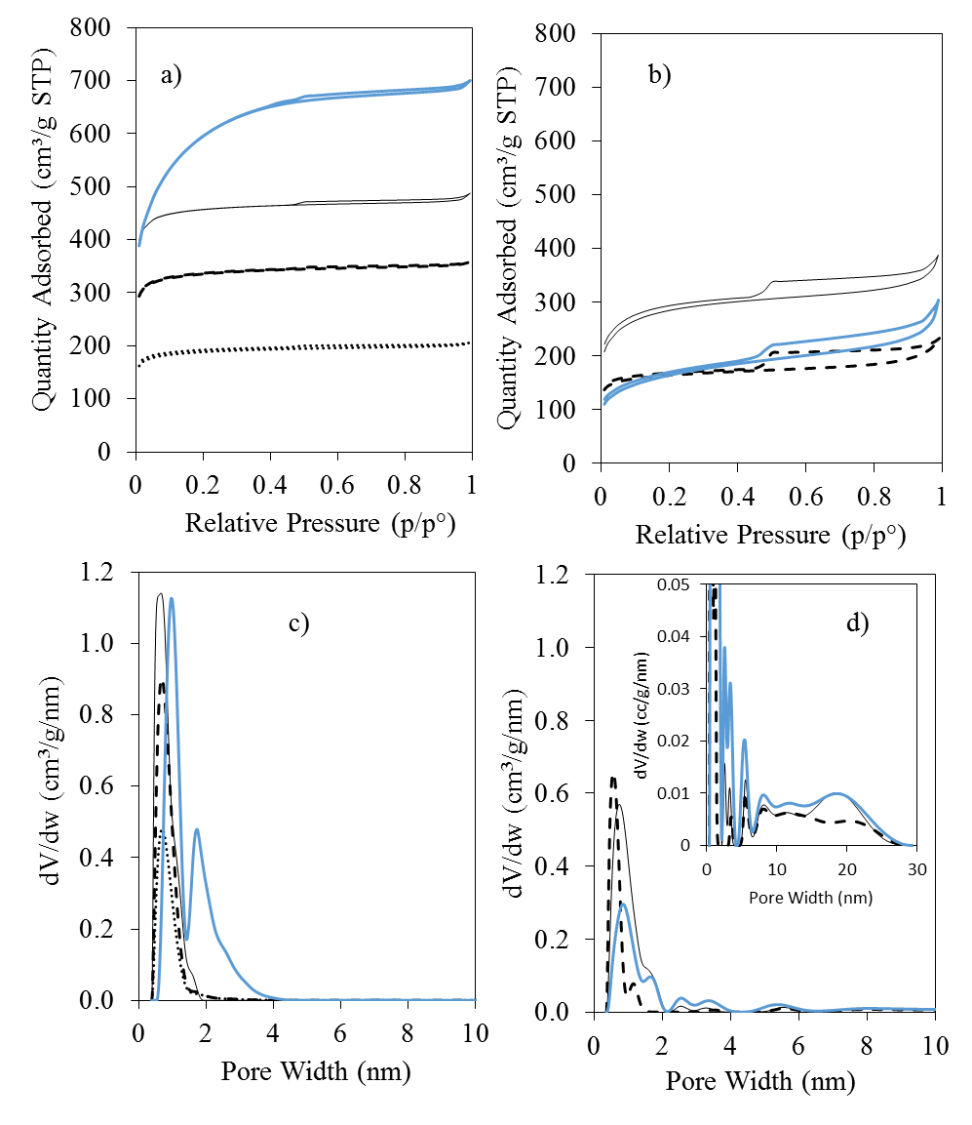

Fig. S1. Isotherms and pore size distribution of AC from petcoke activated with a chemical reagent to carbon mass ratio of 2 KOH a and c) and NaOH b and d), at 500 ᵒC (dotted line), 600 ᵒC (dashed line), 800 ᵒC (black solid line) and after 30 minutes steam exposure at 800 ºC (blue solid line).

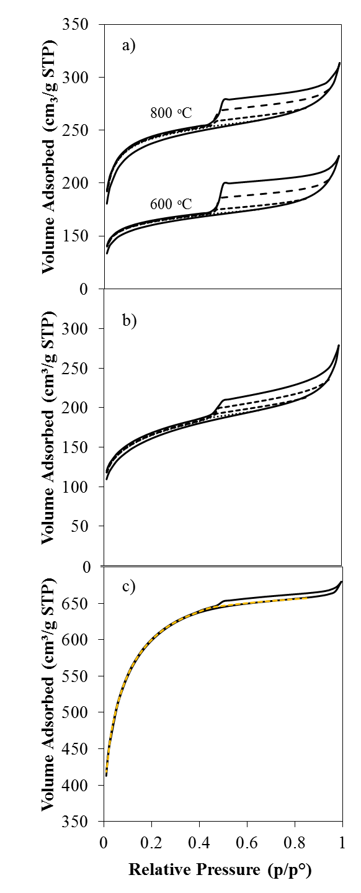

Fig. S2. Isotherm at 0.65, 0.85 and 0.99 P/P0 (dotted, dashed and solid lines, respectively) of AC produced from petcoke activated with NaOH at 600, 800 ºC a) and at 800 ºC steam exposed b). Isotherm at 0.85 and 0.99 P/P0 of AC from petcoke activated with KOH in a chemical reagent to carbon mass ratio of 2 at 800ºC steam exposed c).

Fig.S3. SEM images of ultramicrotomed particles taken at the core of petocke a and b), AC with KOH at 600ºC c and d), and AC with KOH at 800ºC e and f. Chemical reagent to carbon mass ratio of 2

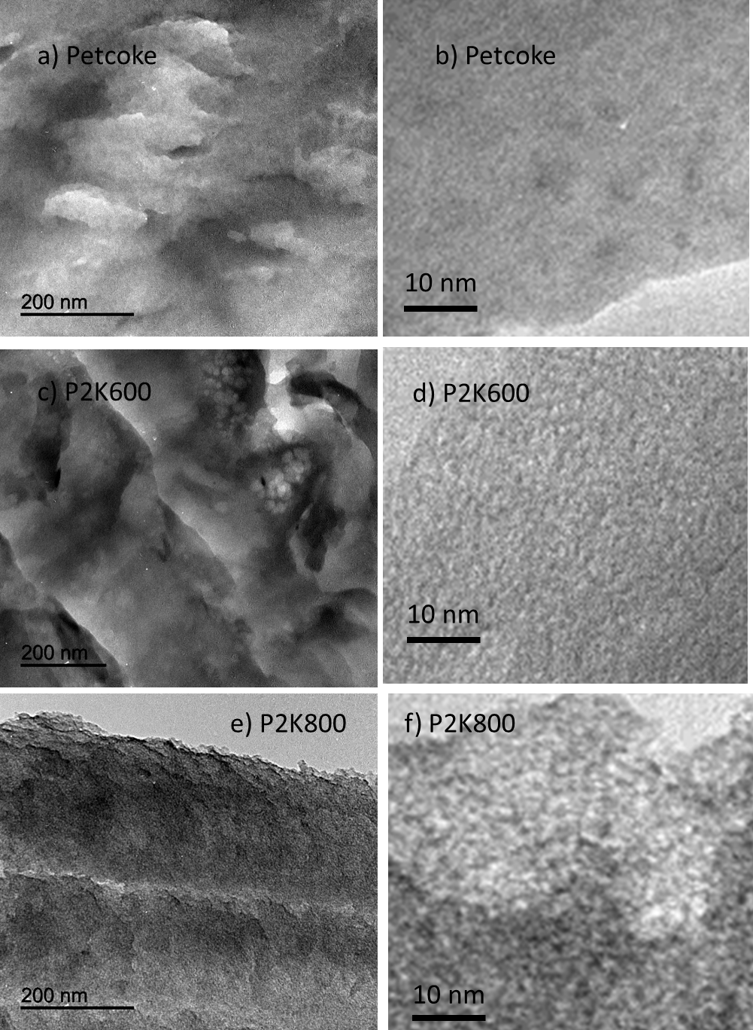

Fig. S4. Relationship between sulphur content and pore volume developed on AC from activation of petcoke with NaOH (△) or KOH (▲) at temperatures between 400 and 800 ᵒC with a chemical reagent to carbon mass ratio of 2, or at 800 ᵒC with chemical reagent to carbon mass ratios between 0.5 and 5.

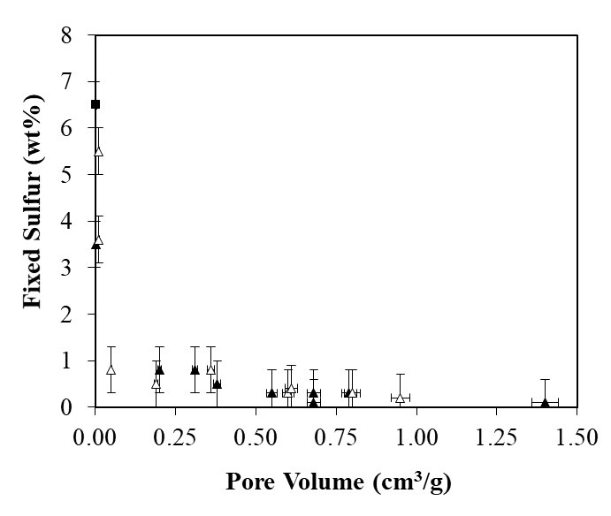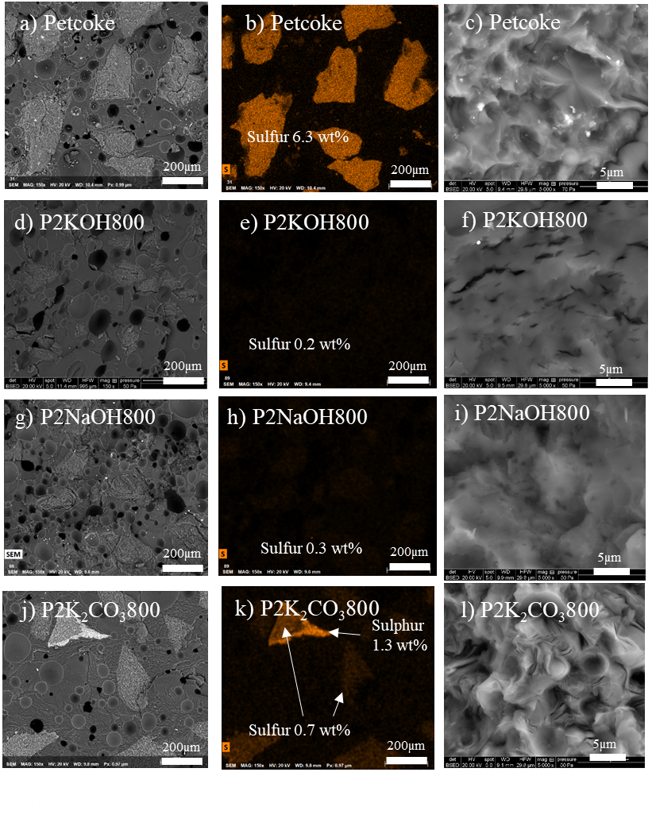

Fig. S5. SEM images and sulfur mapping of cross-sectioned particles of petcoke: a), b), and c), raw; d), e) and f) after activation with KOH; g), h) and i) after activation with NaOH; and j), k) and l) after activation with K2CO3. All activation temperatures were 800 ºC, and the chemical agent to carbon mass ratios were 2.

Fig.S6. SEM images and sulphur mapping of cross-sectioned particles of petcoke a, b, and c), AC with KOH in a chemical reagent to carbon mass ratio of 2 at 500 ºC d and e), 800 ºC f, g and h) and 800 ºC after 30 min steam exposure i, j and k).

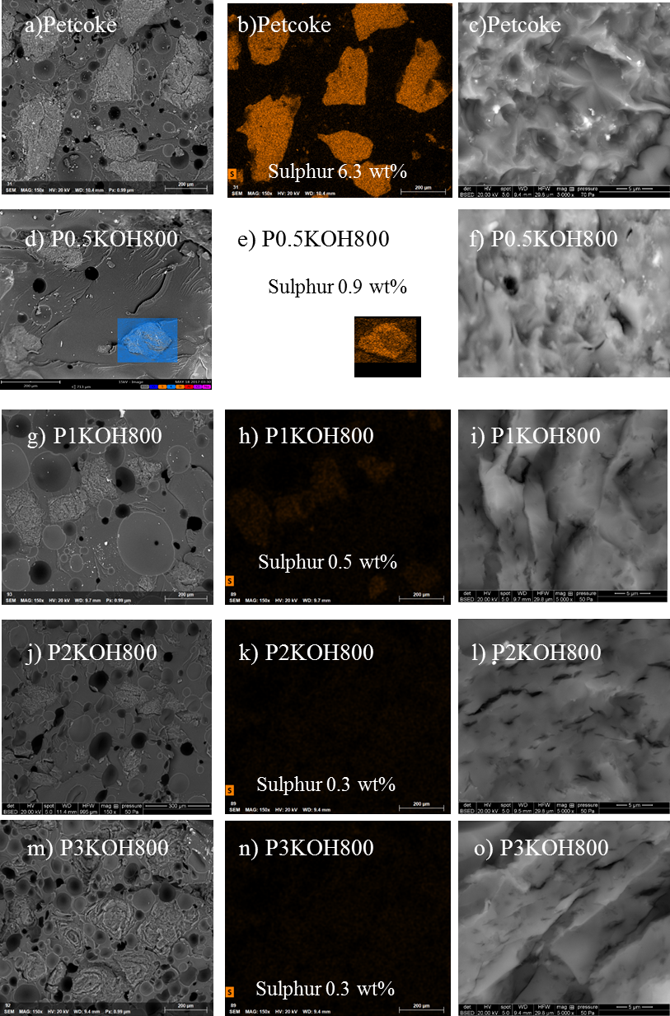

Fig.S7. SEM images of cross-sectioned particles taken at the core or edge of AC with KOH a and b), KOH with steam addition c and d), NaOH e and f) and NaOH with steam addition g and h). Chemical reagent to carbon mass ratio of 2, 800 ºC or 800 ºC with 30 min steam exposure.

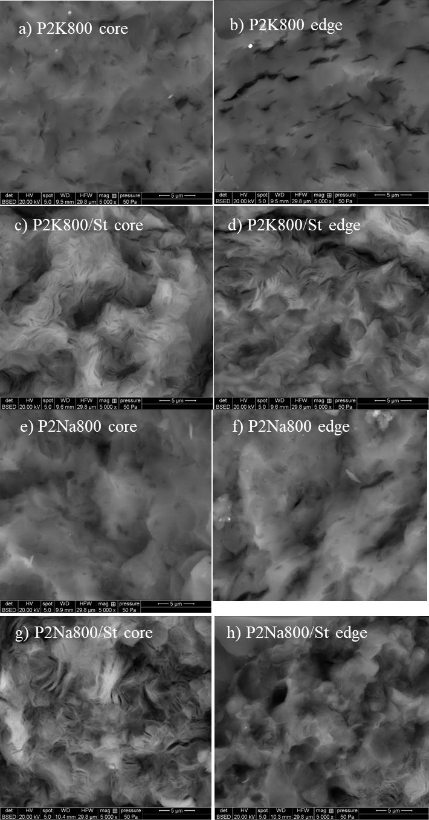

Fig.S7. SEM images of ultramicrotomed particles taken at the core of petocke a,b,c and d), AC with KOH at 600ºC e and f), and AC with KOH at 800ºC g and h. Chemical reagent to carbon mass ratio of 2.

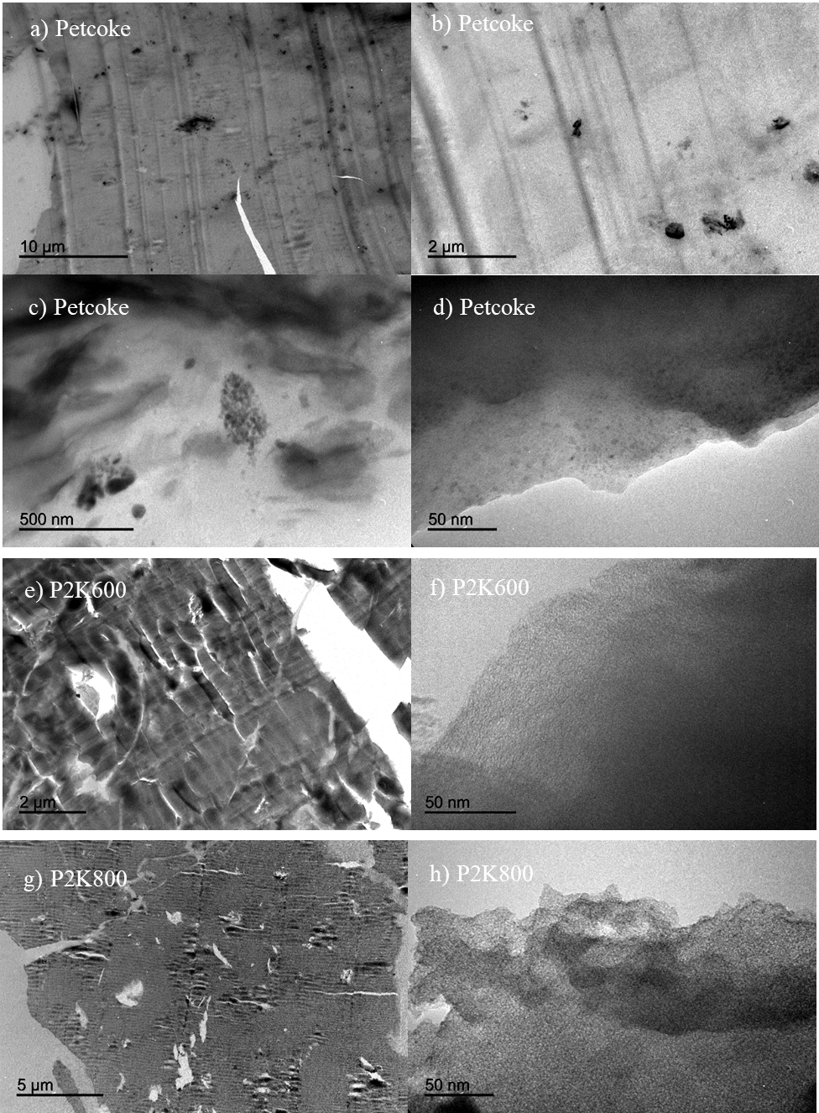

1.