Fig. A.1. Iberian and extra Iberian distribution of Scrophularia arguta and location of the studied population (red star).

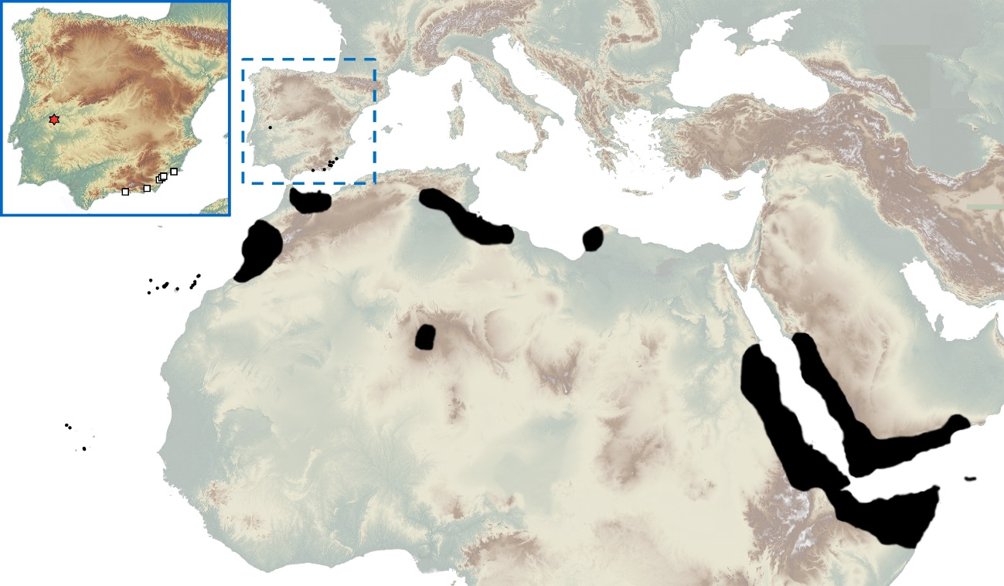
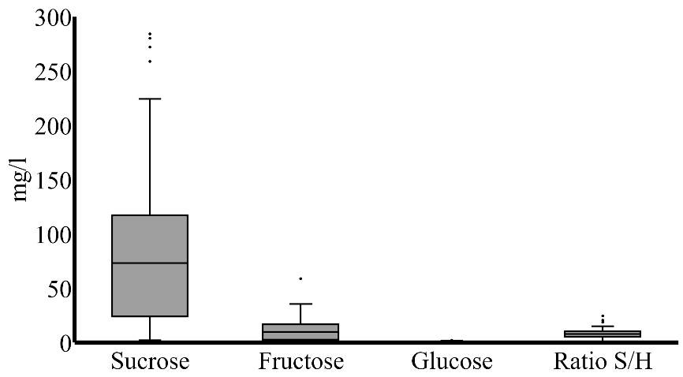
Fig. A.2. Nectar characteristics of Scrophularia arguta. S, sucrose; H, hexose (fructose + glucose).

Population dynamics of sections in sectors A and B
In section I, most Scrophularia arguta individuals, which were usually small and non-blooming, were located in rock cracks and crevices. A large proportion of individuals in section VIII were found on terraces above ground level and most managed to flower and fruit. Sections IX and X resembled those of the sections below them, except that many of their individuals were found in cracks in the wall. Finally, individuals in section XI were only present in stony zones of the open area and, more precisely, in rock cavities formed against the ground. The characteristics of each individual in this section depended on the size of the stony zone; consequently, some plants were similar to those in sections II and III, whereas others resembled those inhabiting sections IV–VII.
In regard to the number of individuals in the studied population, sectors at the base of the wall and in nearly permanently shaded areas (sections II–III) harboured the largest numbers of small seedlings (<4pl) and immature plants (>4pl) (Fig. A.3A–C), and they also had the highest plant densities (Fig. A.3F–H). The next sections with the largest number of individuals were VIII (mostly terraces on the wall) and XI (the open area) (Fig. A.3A–C). The caves constituting sections IX and X, the smallest sections, contained the smallest number of individuals (Fig. A.3A–C). These latter two sections had a high density of individuals. In contrast, the sections VIII and especially XI, which encompassed 83% of the study area, had a low individual density (Fig. A.3F–H).
With respect to flowering (Fig. A.3D), sections IV–VII were notable in terms of both the number and density of flowering individuals, whereas flowering was quite reduced in section II. Similar to observations during the vegetative state, the density of flowering and fruiting individuals in the caves (sections IX and X) was remarkable. A second flowering peak was observed, or inferred to have occurred, in some sections around mid-May. Finally, section III stood out in regard to the number of fruiting individuals (Fig. A.3E). Most sections were characterized by two fruiting peaks; the exceptions were sections II and IX, which had a single peak that coincided with the second fruiting peak of the other sections. With respect to the density of fruiting individuals (Fig. A.3I–J), section III was also distinctive, as were the cave areas and section II (shaded area).

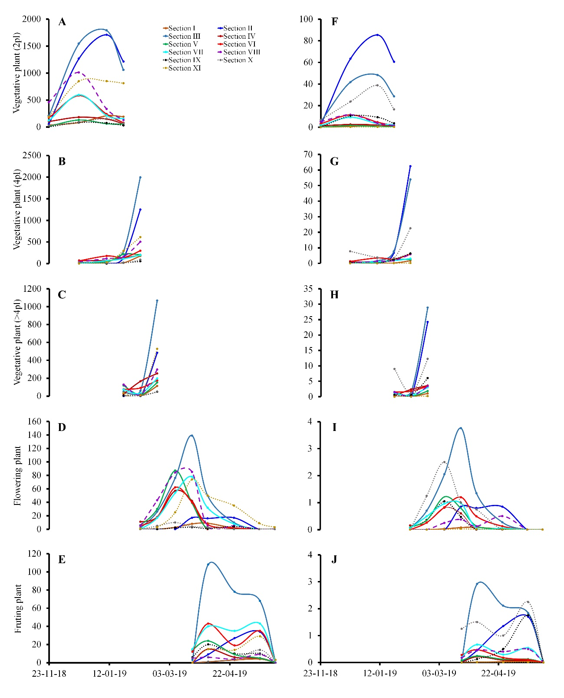
Fig. A.3. Population dynamics of Scrophularia arguta. (A–J) Number (A–E) and density (F–J) of S. arguta individuals in sections I–XI at different developmental phases. The following stages are indicated: 1-2 pairs of leaves (2pl), 3–4 pairs of leaves (4pl), and >4pl (immature plants with more than 4 pairs of leaves), flowering plants and fruiting plants.

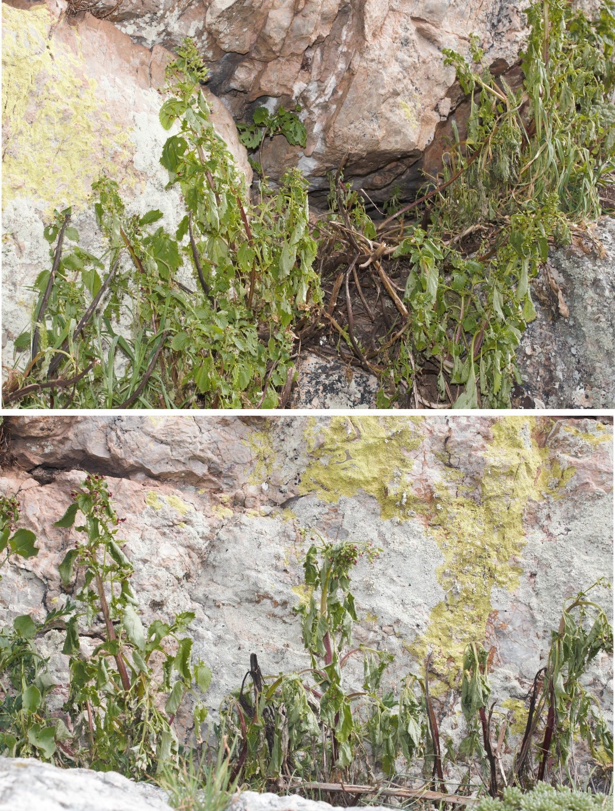
Fig. A.4. Effect of drought on individuals of Scrophularia arguta during 2016.

Seed dispersal by wind
We carried out a pilot study on the terrace of our laboratory using chasmogamous fruit-bearing plants freshly collected from the field. We spread a large white cloth on the floor of the terrace and placed the plant to be analysed at one end. Using a hair dryer, we applied a simulated wind gust, whose speed was measured with a digital anemometer, and measured the dispersal distance (in cm) of the chasmogamous seeds. The wind speed at the nearest meteorological station to the study population during the seed dispersal period averages approximately 13.39 km/h and ranges between 13.1–14.1 km/h.
In the first experiment, we used six plants with an average height of approximately 33.3 cm (range of 25–46 cm). When we applied a simulated wind gust of 22 km/h, the average dispersal distance of chasmogamous seeds was 81.25 cm. When we repeated the experiment at a wind speed of 35 km/h, the seed dispersal distance was 152.5 cm. Finally, we repeated the experiment using 11 other plants (mean height = 37 cm; range 21–64 cm) and a simulated wind speed of 35 km/h, which projected the seeds an average of 148.7 cm (range of 117–177 cm).

